FET Funding Available

The Scottish Landfill Communities Fund (SLCF) and FET Awards

The Scottish Landfill Communities Fund (SLCF) is a tax credit scheme linked to Scottish Landfill Tax. The Scheme encourages landfill site operators to provide contributions to Approved Bodies who can then pass the funds onto community and environmental projects. Fife Environment Trust (FET) is one such Approved Body.

Since the establishment of the Scottish Landfill Communities Fund, Fife Environment Trust (FET) has awarded grants to 245 eligible projects with a combined award figure of over £7.3 million. The FET contribution to projects has helped lever in match funding totaling approximately £22.2 million.

The Board of Fife Environment Trust recently met to consider 11 large grant requests for funding. Of the 11 applications submitted, the Board agreed to approve funding towards 10 projects including:

£49,999.14 to Footprint East Neuk towards costs associated with the upgrade of a path in Dreelside Woods in the East Neuk of Fife.

£30,806 to Tayport Community Trust towards costs associated with the installation of 88 solar panels in the grounds at the Larick Centre in Tayport.

£50,000 to St Andrews Harbour Trust towards costs associated with repairing the walkways at St Andrews Harbour.

£50,000 to Cellardyke Tidal Pool Ltd towards costs associated with the restoration of the tidal pool at Cellardyke.

£31,770 to Friends of Craigtoun towards the costs associated with replacing the roof covering on the long south facing roof of the old potting shed in Craigtoun Park.

In total, £390,500.14 was committed by the Trust for projects to improve public amenities.

Selection of Large Projects Recently Completed

Jubilee Hall Regeneration and Recovery Project

The Burnturk and Kettlehill Community Trust applied to Fife Environment Trust for a contribution towards the costs extending the Jubilee Hall in Burnturk and improving heating and ventilation, whilst also making the hall fully accessible for anyone who requires to use it.

Total Project Cost - £155,002.58

FET Contribution - £50,000.00

FET Contribution - £13,709.15

Letham Glen Bat House and Night Garden

Fife & Kinross Bat Group applied to Fife Environment Trust for a contribution towards creating a unique bat house and night scented garden in Letham Glen, Fife.

Total Project Cost - £18,095.85

FET Contribution - £13,354.10

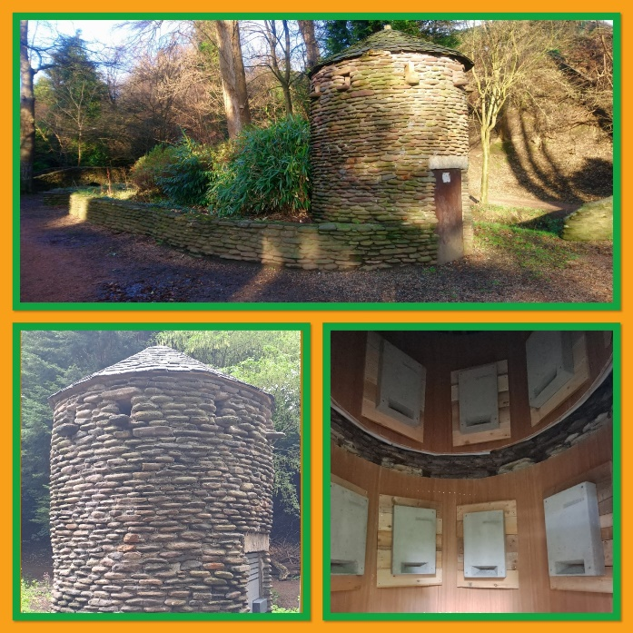


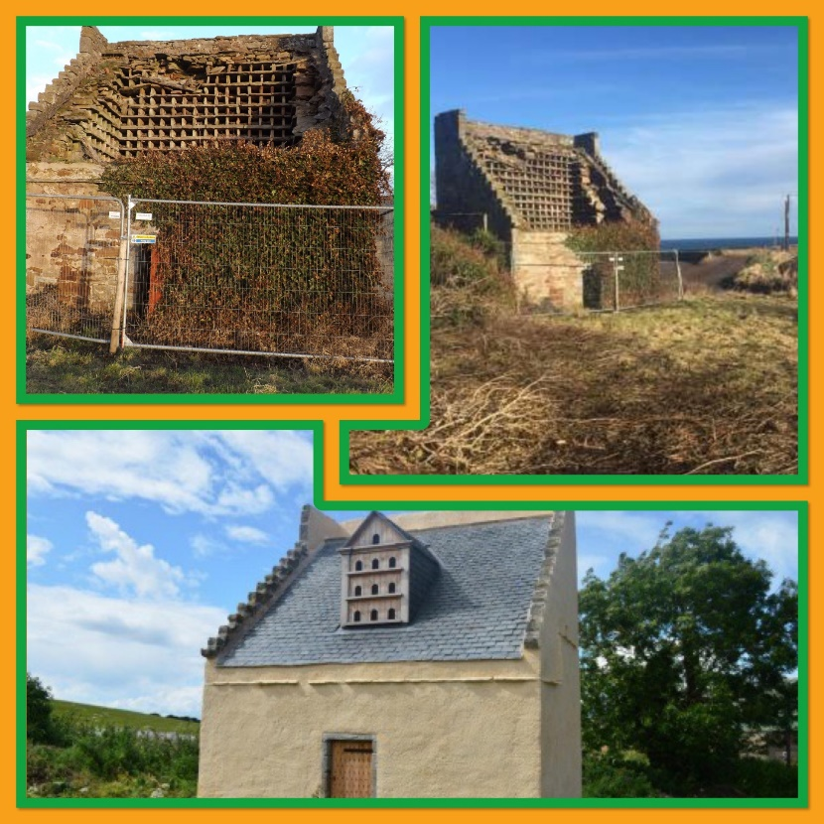

BDCT Green Space Project – Historic Doocot Restoration

The Boarhills and Dunino Community Trust (BDCT) applied to Fife Environment Trust for a contribution towards the costs of the restoration of a dilapidated seventeenth century doocot in Boarhills, Fife.

Total Project Cost - £69,086.40

FET Contribution - £49,730.40

FET Contribution - £13,709.15

Selection of Small Projects Recently Completed
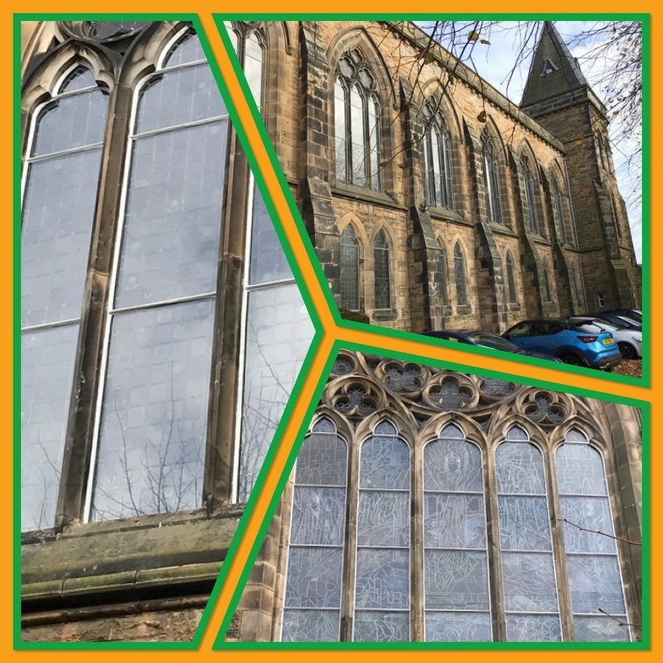

Window Refurbishment

St Bryce Kirk applied to Fife Environment Trust for a contribution towards the costs of upgrading the upstairs windows in St Bryce Kirk in Kirkcaldy. This included a complete overhaul of the protective glazing of 133 individual panes of glass.

Total Project Cost - £42,326.00

FET Contribution - £10,000.00



AoG Central Community Kitchen Project

AoG Central applied to Fife Environment Trust for a contribution towards the costs of the supply and installation of a community kitchen within the AoG Central in Fraserburgh.

Total Project Cost - £14,144.86

FET Contribution - £10,000.00

Application Deadlines and Funding Threshold Levels

The next deadline for the submission of large grant applications for awards up to £50,000 is Monday 30th September 2024. The Board will meet to discuss all September submissions at the next meeting of the Trustees scheduled for Thursday 28th November 2024. Applications to our Small Grants Scheme for awards up to £10,000 are considered on a rolling basis.
The Board can consider applications from community groups/organisations looking to improve public amenities, restore historic buildings/structures or undertake biodiversity projects.

If you would like to find out more about the funding available from Fife Environment Trust, please visit our website or contact our Policy Officer via the details listed below.

Please direct all correspondence/feedback regarding the newsletter to:

Email: Fiona.scott@fife.gov.uk

Website: www.fifeenvironmenttrust.org.uk

