FET Funding Available

The Scottish Landfill Communities Fund (SLCF) and FET Awards

The Scottish Landfill Communities Fund (SLCF) is a tax credit scheme linked to Scottish Landfill Tax. The Scheme encourages landfill site operators to provide contributions to Approved Bodies who can then pass the funds onto community and environmental projects. Fife Environment Trust (FET) is one such Approved Body.

Since the establishment of the Scottish Landfill Communities Fund, Fife Environment Trust (FET) has awarded grants to 262 eligible projects with a combined award figure of over £7.7 million. The FET contribution to projects has helped lever in match funding totaling approximately £24.9 million.

The Board of Fife Environment Trust recently met to consider 13 large grant requests and 3 small grant requests for funding. Of the 16 total applications submitted, the Board agreed to approve funding towards 12 projects including:

£30,000 to Fife Forthview Parish Church Inverkeithing towards costs associated with the repairs of the external fabric, including clock housing repair, repointing of the stonework and redecoration of the louvres at Inverkeithing Parish Church.

£20,000 to Dalgety Bay & Hillend Community Council Playpark Subgroup towards costs associated with the improvement of the current play facilities at Inchmickery Playpark in Dalgety Bay.

£30,000 to Leslie Baptist Church towards costs associated with various upgrades within the church to make better use of the space and improve accessibility.

£20,000 to Dysart Community Council towards costs associated with the improvements of the current play facilities at Cook Street Playpark in Dysart.

£4,000.76 to St Andrews environmental Network Ltd towards the costs associated with the installation of a low-energy, efficient heating system at the Eco Hub in St Andrews.

In total, £248,319.76 was committed by the Trust for projects to improve public amenities.

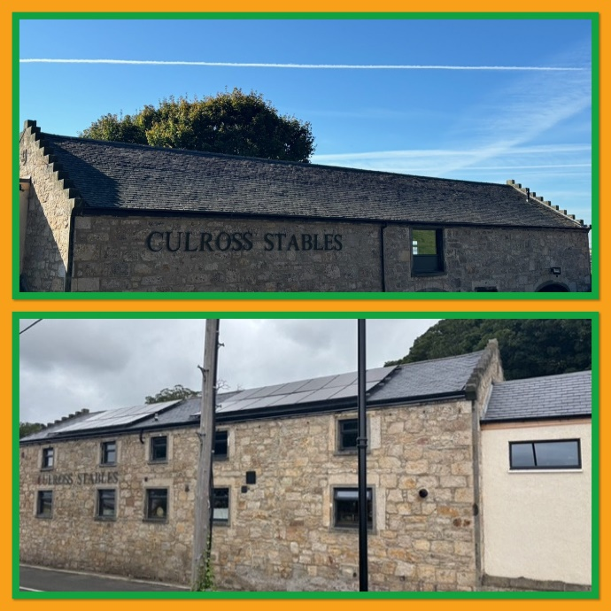
Selection of Large Projects Recently Completed

Culross Stables Community Hub – New Roof

Culross Stables Community Hub applied to Fife Environment Trust for a contribution towards the replacement of the roof at the community hub which was rotting.

Total Project Cost - £41,982

FET Contribution - £29,907

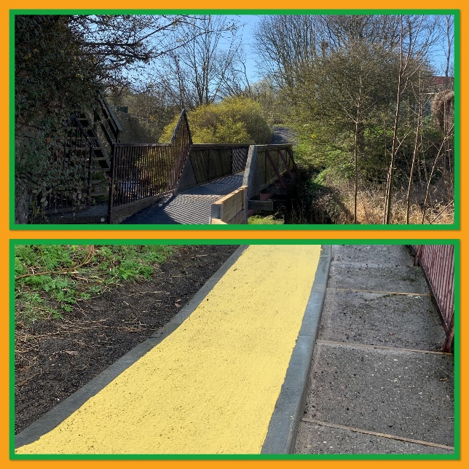

Dreelside Woods Community Asset Path Upgrade

Footprint East Neuk applied to Fife Environment Trust for a contribution towards the costs of upgrading the paths through the Dreelside Woods in Anstruther.

Total Project Cost - £153,974.23

FET Contribution - £49,999

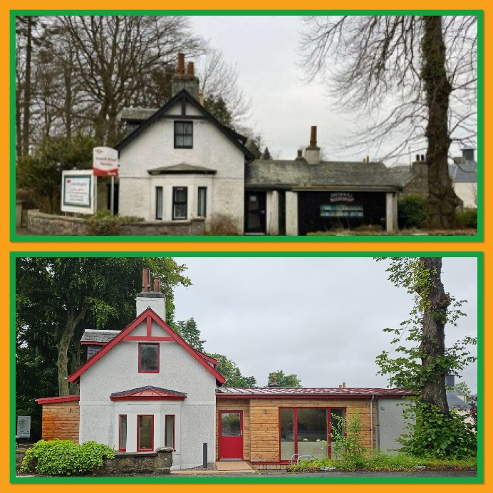
Murtle Market Community Recycling Project

Camphill Rudolf Steiner Schools applied to Fife Environment Trust for a contribution towards the costs of retrofitting a disused building on Murtle Estate into an energy efficient building, which will operate a community recycling project called Murtle Market.

Total Project Cost - £518,424

FET Contribution - £50,000

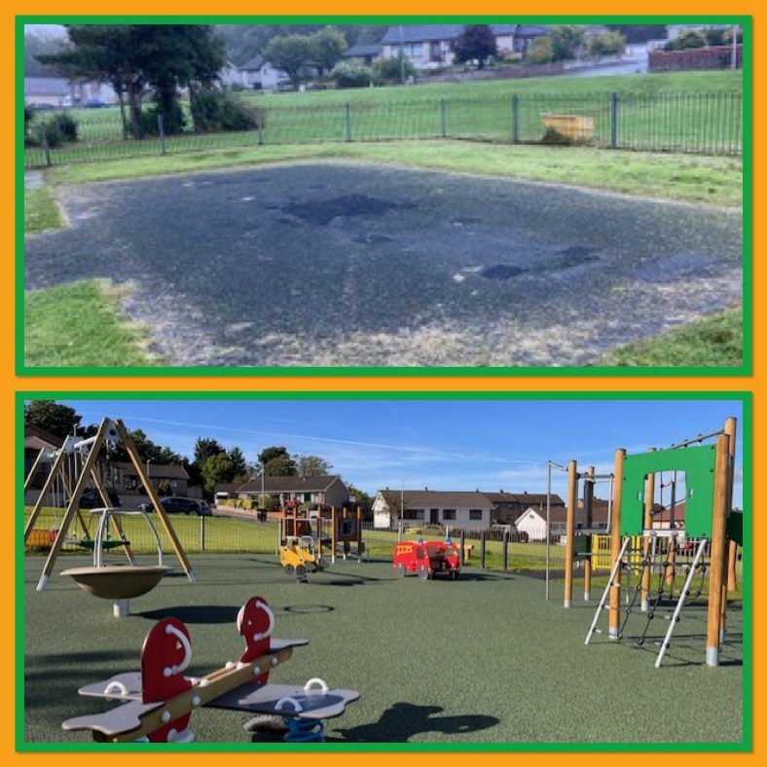

Keirs Brae Playpark Project

Cardenden Playpark Committee applied to Fife Environment Trust for a contribution towards the costs of the the installation of new play equipment at Keirs Brae playpark in Cardenden.

Total Project Cost - £88,023

FET Contribution - £30,000

Application Deadlines and Funding Threshold Levels

The next deadline for the submission of large grant applications for awards up to £20,000 is Tuesday 30th September 2025. The Board will meet to discuss all September submissions at the next meeting of the Trustees scheduled for Tuesday 25th November 2025. Applications to our Small Grants Scheme for awards up to £10,000 are considered on a rolling basis.
The Board can consider applications from community groups/organisations looking to improve public amenities, restore historic buildings/structures or undertake biodiversity projects.

If you would like to find out more about the funding available from Fife Environment Trust, please visit our website or contact our Policy Officer via the details listed below.

Please direct all correspondence/feedback regarding the newsletter to:

Email: Fiona.scott@fife.gov.uk

Website: www.fifeenvironmenttrust.org.uk

